**7.3 Do Now Quiz**

*Pick any 3 problems to solve for 9 points. If you solve all 4 problems, you will earn 10 points. You can earn partial credit for showing all your work. This must be completed silently & independently*

1. Solve for x in simplest radical form.

Untitled-6 copy

2. Solve for x and y in simplest radical form.

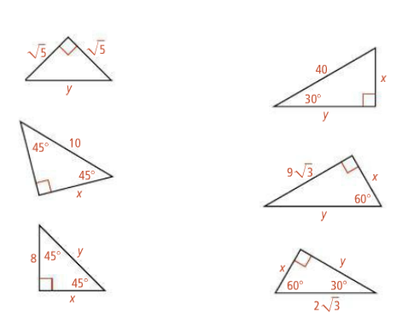

3. Solve for x in simplest radical form.



4. Solve for y in simplest radical form.

